**Who is the ESM Administrator?**

The two key roles involved in ESM administration are:

1. Product administrator: creates and maintains the offers, products, and services in your catalog. Product administrators know your business offers inside out. They use the Product Designer, Rules Builder, and Pricing Designer to create and maintain your business offers. If you’re a product administrator, you can find information specific to ESM product design in the Get to Know Enterprise Sales Management course. You don’t need any ESM-specific training to build products and services in ESM, but you can learn more about this in the Build CPQ Solutions for Industries course.
2. Org administrator: responsible for maintaining, upgrading, and migrating the org containing the ESM application used by your organization. This course is designed to support org administrators in their day-to-day tasks. Throughout the course, you see the org administrator for the ESM installation referred to as the ESM administrator.

**What Skills Does an ESM Administrator Need?**

If you’ve worked as a Salesforce administrator before, you already have some of the knowledge, skills, and accreditations you need for the role:

* Salesforce Administrator certification
* Knowledge of the Salesforce Industries object model
* Experience creating and importing data
* Familiarity with installing and configuring packages
* Experience in managing users and profiles
* Ability to create and maintain reports and queries
* General database maintenance skills, such as database management and troubleshooting

You should also be familiar with data and security management tools.

**What are the Key ESM Administration Tasks?**

As an ESM administrator, you’ll be managing the ESM org used by your organization. This includes the following tasks:

**Managing users and profiles**

This includes creating and editing users, resetting passwords, granting permissions, and configuring data access. These are ongoing tasks, completed whenever new users are added to the system, or when user details change. You can learn how to do this by completing the User Management module in Trailhead. Go to the Resources section for a link to the module and the documentation, where you can learn how to set up automated flows to automatically assign Salesforce Industries licenses to users based on specified criteria.

**Importing and exporting org data**

In the early stages of your ESM implementation, you may need to import or export org data frequently. This may be:

* from one ESM org to another.
* between an org and a Git repository.
* from the Process Library to your org.
* from a JSON file to a Git repository or an org.

You’ll learn later in this course how to use the IDX Workbench desktop application to migrate data.

**Installing and configuring orgs**

ESM is part of your company’s initial Salesforce Communications Industry package. You or your implementation partner install the package with support from Salesforce.

Once your installation is complete, you’re usually required to upgrade it, in line with Salesforce releases, three times a year. Although the dates change each year, releases are generally around the USA’s Spring (February), Summer (June) and Winter (October) seasons.

You’ll learn the process for completing updates and patches, and troubleshooting upgrade issues in the next lesson.

**Administering content**

Occasionally, you may need to administer some elements of the content, such as proposal templates. Your ESM implementation provides standard templates that you can update in the Contract Lifecycle Management application. Find out more in the Configure and Maintain Proposals module of this course.

**Migrating org components**

You might have a test org, a development org, and a production org. As the ESM administrator, you migrate ESM components from one org to another using the IDX Workbench. Complete migrations as part of your product release cycle, and according to your Agile Sprint timetable. Learn more about migration in the Migrate ESM to Another Org module of this course.

**What Am I Installing?**

The ESM application has prebuilt modules and application components designed for business-to-business (B2B) communications providers. These modules and components are built on the core platform and products and released as part of the Salesforce Industries Communications, Media, Energy and Utilities application suite. This application suite includes:

* Data model extensions
* A reference product catalog model
* A process library that captures standard business support systems (BSS) processes
* Integrations with external applications or stubs

The Salesforce Industries Communications and Media application suite uses three platform components:

* **Core platform**

The platform includes OmniStudio, with OmniScripts, Cards, DataRaptors, Lightning Web Components, and Integration Procedures.

* **Core products**

The products include Enterprise Product Catalog (EPC), Industries CPQ, and Contract Lifecycle Management (CLM) Document Generation.

* **Data model**

A communications-specific data model.

**How Do I Access an Org with ESM?**

ESM is included with Salesforce and Industries CPQ, therefore we assume that you already have these implemented in your organization. If you want to try out the latest version of ESM, you have three different approaches:

* Explore ESM: Request a training or trial org.
* Get started with ESM: Install ESM on a Communications Cloud org.
* Upgrade ESM: Upgrade your current ESM installation to the latest version.

Click on each approach below to find out more, then learn about the required post-install maintenance tasks. You’ll learn more about upgrades and installs in the next module, along with migration of components from one org to another.

**Request a Training or Demonstration Org**

Salesforce provides temporary orgs for training and demonstration purposes. If you don’t already have an org, request one on the Enterprise Sales Management page in the Salesforce Industries process library. You need to provide your name and a valid email address, and you’ll receive your login credentials by email once the org is ready.

Once you have your org credentials, you can log in to the org and get started. Enable the Google Maps functionality used to find and select quote member locations on a map by completing the steps to create and add your Google Maps API key. Follow the documentation link provided in the resources section of this lesson, or the demonstration provided in the Out-of-the-Box Integration lesson in the ESM Developer course.

The post-install maintenance tasks outlined in the last section of this lesson are already completed for you. However, if you make any changes to the product model structure in your ESM catalog data, such as adding or removing products, or changing cardinality, you need to run these maintenance jobs from the Vlocity CMT Maintenance application:

1. Product hierarchy maintenance
2. Clear managed platform cache
3. Refresh platform cache

This ensures your changes are visible when creating and amending quotes and orders.

**Install ESM on an Org with Salesforce Industries CPQ Installed**

What if ESM is not installed on your org? First, check the org has the latest Salesforce Communications Cloud  (Industries Communications, Media, Energy, and Utilities Winter ‘22 or later) installed, and that all the appropriate post-install steps have been completed. Once you’re satisfied that all is working as it should be, assess the impacts that an ESM installation will have on your existing components and workflows, including how your product model may need to change to incorporate ESM functionality.

All your checks and customizations are complete. It’s time to do your install.

Download the ESM installation components in YAML format from our repository, and then install the IDX Workbench. Use the Workbench to migrate the components to your org, and then complete some final post-installation configuration, such as for permissions and activations. You’ll learn more about this in the Migrate ESM to Another Org module later in this course.

**Upgrade ESM on an Org that Already Has ESM Installed**

You’ve developed some pretty amazing customizations on your demo org, and now you want to move these over to the ESM development and testing org used by your company. You can upgrade or migrate specific components to an org using a desktop application called the IDX Workbench. You’ll learn about this process in the Migrate ESM to Another Org module later in this course.

**Post-Install Maintenance Tasks**

For any installation or upgrade, once you complete all the required updates and configurations, run the maintenance jobs to ensure your configurations are implemented.

To run the maintenance jobs:

1. From the App Launcher, select **Vlocity CMT Administration**.
2. Under the Admin Console, click **Maintenance Jobs**.
3. Run the jobs in the order shown below, ensuring that each job completes before starting the next one:
   1. Account hierarchy maintenance
   2. Interface implementation maintenance (merge)
   3. Product hierarchy maintenance
   4. Clear managed platform cache
   5. Refresh platform cache

To find out more about what each job does, refer to the Running Maintenance Jobs documentation linked in the resources section of this lesson, or complete the EPC Maintenance lessons in the Build CPQ Solutions for Industries course.

**Before You Start**

As a wise person once said, proper planning and preparation prevents poor performance, and this is especially the case when you’re thinking of installing, upgrading, or migrating ESM. Many of the preparatory processes are the same whether you’re installing ESM onto your existing Salesforce Industries CPQ org or migrating a new feature from your trial org over to your production org. In this module, you’ll learn the steps to take to complete installs, upgrades, and migrations, and in this lesson you’ll focus on ensuring you’re properly prepared.

**Check What You Have**  
You’ll need to have the latest version of Salesforce Industries Communications Cloud installed and tested on your target org before you complete any ESM installations, migrations, or upgrades.

To check the version, go to **Setup**. In the Quick Search type **Install**, then select **Installed Packages**. You should see Vlocity CMT with a version number of 900.444 or later.

**Understand the Impacts**  
A link to the ESM release notes (located in the Communications and Media Applications section of What’s New in CME) is included in the Resources section of this lesson. Check the release notes to ensure you definitely want to install or upgrade ESM on your chosen org. Think carefully about the processes and components that will be affected and plan for any impacts that the installation or upgrade will have on other systems in your organization.

**Reconfigure If Required**  
If you’re upgrading an existing org, especially one that doesn’t already have ESM installed, take some time to consider and reconfigure the product models and workflows in the org to take account of the ESM-specific models. Also, think about any other configurations or functionality in the target org that could cause issues during the migration of the ESM components or when using the workflows after migration. For example, do you have any custom action buttons or OmniScripts that will need to be reconfigured? Check any target org customizations that you’ve made are fully documented and, where you can, use a repository such as Git to back up those customizations.

|  |  |
| --- | --- |
| 📝 | Once you install, you cannot uninstall - and once you upgrade, you cannot downgrade to an earlier release. There is no going back! |

**Gather Your Instructions and Downloads**

The instructions for installation and upgrades in the documentation (linked in the Resources for this lesson) are very detailed and contain links to the appropriate installation packages and supporting documentation for each release. There are different installation and upgrade packages for production orgs and sandbox orgs, so take care to use the appropriate installation URL, download, and installation assistant.

**YAML Files**  
ESM uses a desktop application called IDX Workbench to complete installations, upgrades, and patches. If you’re updating an existing current Industries Communications org with no previous ESM installation, you can download the appropriate YAML file and add it to your IDX Workbench repository as the source for your migration. You’ll learn how to do this in the next lesson.

**DataPacks**  
If you’re updating your target org with customizations that were created in your trial org, first create a DataPack from your trial org as your source. A DataPack is a collection of components and related functionality that are packaged for migration from your source org to your target org–for example, from your trial org to your production org. Creating DataPacks is outside the scope of this training, as it is covered in detail in the OmniStudio Developer Tools module in Trailhead and in the associated documentation, both of which are linked in the Resources section of this lesson. Once your DataPack is created, you’ll use the IDX Workbench to migrate your DataPack into the target org.

**Post-Migration Preparation**  
After you complete your installation, upgrade, or DataPack migration, there are post-installation steps to ensure your Salesforce Industries applications are set up to suit your requirements. This includes installation and activation of some components, configuration of settings, and testing. Some of these steps are optional, or may differ depending on your organization’s requirements. Read through them carefully, along with the release notes, to determine what steps are appropriate for your business before you start your installation or upgrade.

**Prepare Your Target Org**

Often, some components that were used in an earlier release of ESM must be deleted from your target org. In the scenario for this lesson, the target org would be your QA org. The components must be deleted either because they are no longer used in later releases, or to ensure that they can be replaced by updated components. To delete these components:

1. Log in to the target org.
2. Delete the **cfB2bSampleAppCard** lightning component from your target org.
3. From **Settings**, select **Setup**.
   1. In Quick Find, enter Lightning and click **Lightning Components**.
   2. In the list of Lightning components, go to cfB2bSampleAppCard. Click **Del**and then click **OK**to confirm.

**Set up and Configure the IDX Workbench**

The IDX Workbench is used to migrate OmniStudio DataPacks and Salesforce metadata between a source and a target.

Sources can be orgs, Git repositories, the OmniStudio Process Library, or a JSON file. Targets can be orgs or Git repositories, as shown here.

| **Source** | **Target** |
| --- | --- |
| Salesforce Org | Another Salesforce Org |
| Salesforce Org | Git Repository |
| Git Repository | Salesforce Org |
| OmniStudio Process Library | Salesforce Org |
| JSON file | Salesforce Org |
| JSON file | Git Repository |

The IDX Workbench is a desktop application, so you must install it on your computer. To install the IDX Workbench:

1. Go to the download site and click the link for your platform. When the IDXWorkbench-release.dmg file finishes downloading, run the file.
2. On the Mac operating system, a pop-up window appears. Drag the app into the Applications folder.
3. Open the IDX Workbench application. On the Mac operating system, you might see a message stating that IDX Workbench can't be opened because Apple can't check it for malicious software. To allow IDX Workbench to be opened:
   1. Open System Preferences.
   2. Click Security & Privacy.
   3. Click the General tab.
   4. Click the Open Anyway button for the IDX Workbench application.
4. When you open IDX Workbench for the first time after installing it, the Configure Workspace dialog appears. This is where you specify the source, target, and objects to be migrated.

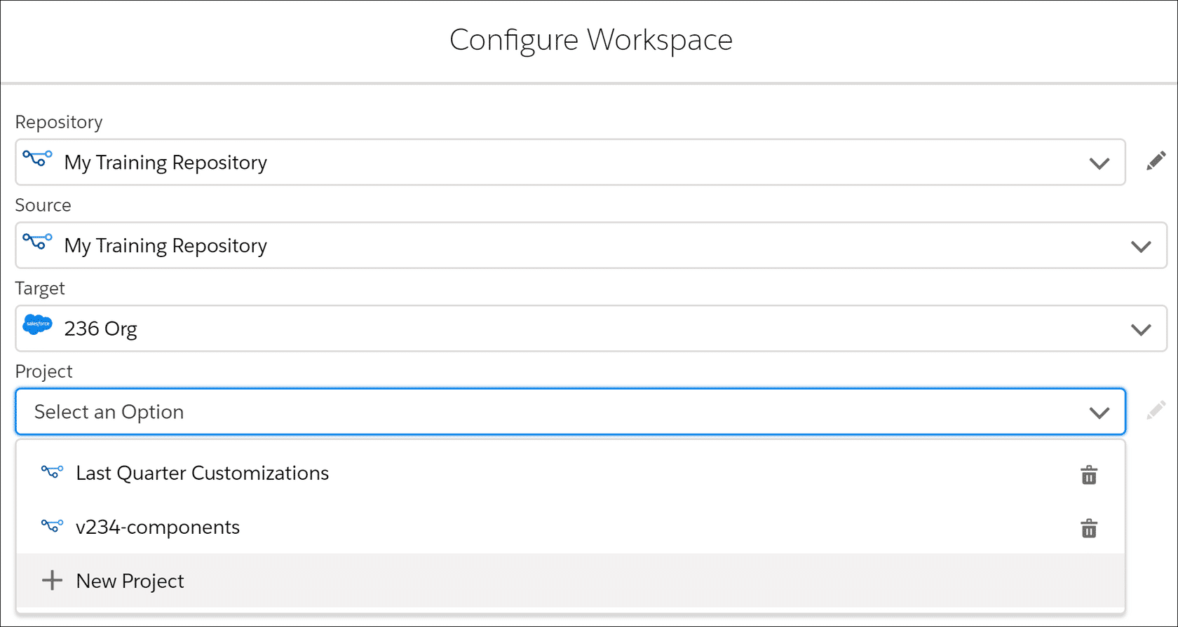

1. Follow the instructions for the source and target specified in your installation or upgrade instructions.

**The Story So Far**

Let’s check where you’re at. You’ve done some great customization work on your trial org, and now you want to copy the work you’ve done into your QA org, which is used to test before amendments are added to the production org. Unfortunately, your QA org doesn’t yet have ESM installed but it was updated recently to the latest release.

You’ve read through the release notes in the documentation regarding your product models, processes, and the impacts that the ESM installation may have on your QA org. You’ve made a few changes to your product model and processes to ensure that the migration will run smoothly. You’ve also ensured that your changes have been fully documented, and that your QA org has been properly backed up in case there are any problems with the migration.

You’ve completed the OmniStudio Explore IDX Workbench module in Trailhead, which is linked in the Resources section of this lesson, and you’re confident that you know how to complete the migration process. You’ve also downloaded the IDX Workbench and installed it on your computer.

You’ve created your DataPack, which contains the integration procedure, OmniScript, and DataRaptors from your trial org that are required to implement your customizations.

Now it’s time to follow the migration instructions. First, you're going to upgrade your QA org by adding the latest ESM release, and then you'll migrate your DataPack.

**Upgrade to the Latest ESM Release**

The first step is to ensure that all the standard ESM release components are installed on your target org. Follow this process if you don’t have ESM installed in your org, or if you want to ensure that all the latest out-of-the-box components are available in your target org.

All the ESM-specific components for the current release are held in a project, which is a YAML file that you can download from the ESM Installation Notes in the documentation available in the Success Community (link included in the Resources).

**Set the Project File as Your Source**

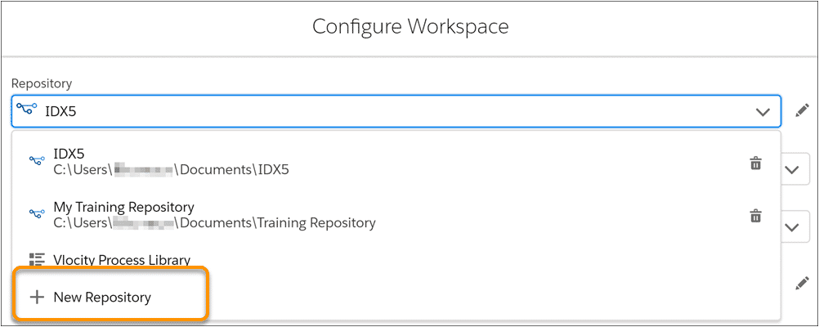

Once you’ve downloaded the YAML file, open your IDX Workbench, click on the pen icon beside the configuration settings at the top of the Workbench, and follow these steps to set the YAML file as your source.

1. Select **+ New Repository** and specify a name and a repository path for your new repository. If the folder doesn’t already exist, the IDX Workbench will create it for you.
2. Using your computer’s file manager, navigate to the repository path and display hidden files.
   1. On a Mac, press Command + Shift +.
   2. On a Windows system, click **View**and then select **Hidden Files.**
3. Copy the YAML file you downloaded earlier and paste it into the hidden .vlocity folder in the repository.
4. Go back to IDX Workbench and click **Cancel**.
5. Click the Edit icon and in Configure Workspace, select the repository. In Project, select the YAML file that shows up in the list.

**Set the Target**

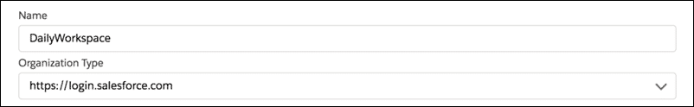

Once you’ve established the source information, the second step is to specify where you want the information to be copied to. This is set in the **Target**of the configuration.

Following the earlier scenario, you’d want your QA org to be displayed as the target. If you don’t see your QA org listed in the Target dropdown, select **+ New Environment**, give your target org a name you’ll recognize later, and set the organization type as the Salesforce Login.

You’ll be redirected to the Salesforce login screen. Log into Salesforce and confirm you’re happy for the IDX Workbench to access your selected org.

Once that’s done, you’ll be directed back to the IDX Workbench configuration page.

**Save and Run the Configured Migration from the IDX Workbench**

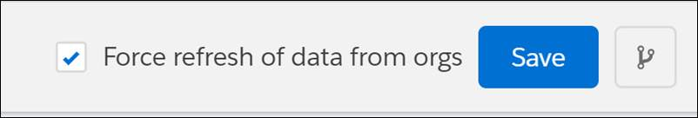

Check your configuration details carefully. Then, click **Save**in the bottom right of the IDX Workbench to run the migration.

**Troubleshooting**

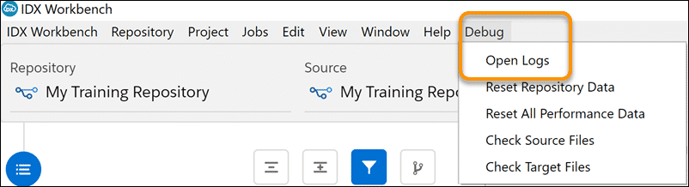

If IDX Workbench encounters any issues with the migration, these will be recorded in the log file.

You can access the log files from the **Debug**menu.

This demonstration is approximately four minutes long and shows you how to:

* Download and install the IDX Workbench.
* Create a repository to store your downloaded YAML file.
* Select the appropriate version of the upgrade package as your source.
* Set the target org.
* Run your migration.
* Check the log file for errors.

**Migrate Specific Components with a DataPack**

Now your target org has all the core ESM components, you can add the customizations you created on your trial org. This can be done using a DataPack as the source.

DataPacks are created in OmniStudio using the export function. As an example, if you were to customize an integration procedure, you’d click the Export button at the bottom of the pane and OmniStudio would guide you through the process of creating a DataPack with all the components that make that integration procedure work. This includes the option to download your DataPack as a JSON file, and add it to an existing library.

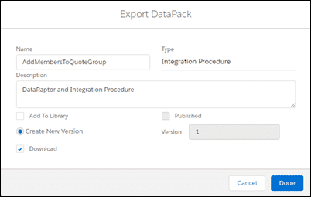

## Migrate a DataPack with IDX Workbench

 IDX Workbench can be used to migrate DataPacks to either an org or a Git repository target. The DataPack includes all the objects you want to migrate in a single JSON file.

**Set up a Repository for Your DataPack**

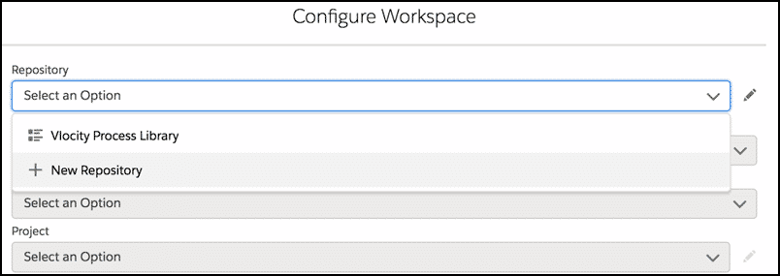

In the IDX Workbench, set up a repository (if you don’t already have one) to hold your DataPack. Watch the demonstration in the previous section if you’re unsure how to do this.

This example uses the My Training Repository set up during the demonstration.

Copy your DataPack into the repository using your file manager.

**Select the Source Type**

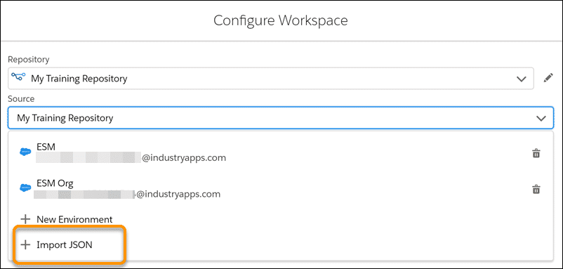

From the Source dropdown, select **+Import JSON**.

**Save and Run the Configured Migration from the IDX Workbench**

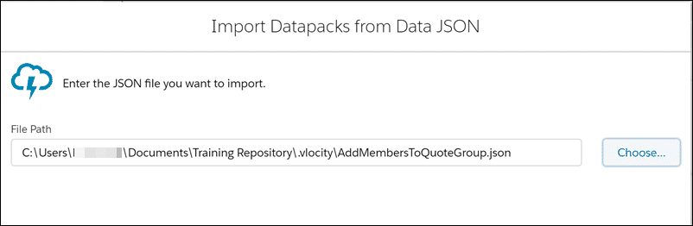

Click **Choose**and select the DataPack JSON file you uploaded into your repository. Click **Done**to continue.

Check your repository, source and target details. Then click **Save**to migrate the required components in the DataPack.

**Troubleshooting**



If IDX Workbench encounters any issues with the migration, these will be recorded in the log file.

You can access the log files from the **Debug**menu.

**Migrate from a Source Org to a Target Org**

If you’ve made several changes in your trial org that you want to copy over to your target org, you can perform an org-to-org migration using IDX Workbench. Note that you’ll use a repository for this, but you’ll set the Source as an org, just as you set the target org in the previous lesson.

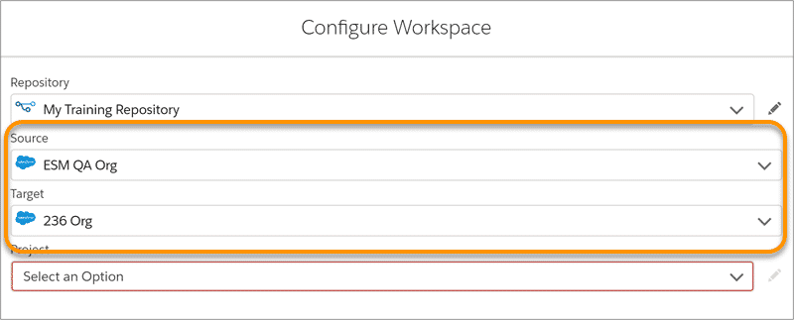

**Implement IDX Projects**

IDX projects are used to specify the exact components you want to implement from the source to the target. Creating and running your project is the final step in the migration process.

To create a project containing all the components you want to migrate, from the **Project**dropdown, select **+ New Project**.

Give your project a name. The project here is called Last Quarter Customizations.

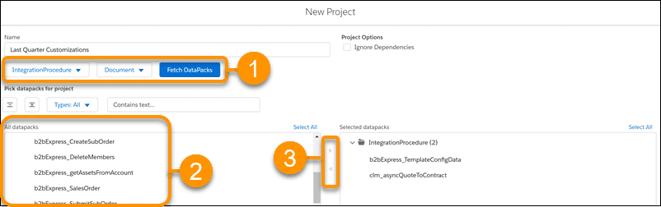

1. Filter the types of customizations that you want to include by selecting the type of component, such as IntegrationProcedure or OmniScript, from the filter dropdowns. Then, click **Fetch DataPacks.**
2. All the DataPacks in your source related to your filters will be shown. Select the DataPack you want from the list.
3. Use the select button to add the DataPack to the Selected DataPacks list. Once you’re done, click **Save**at the bottom of the screen to return to the IDX Workbench configuration settings page. Click **Save**from the Configuration Settings page to run your migration.

**The Story So Far**

You’ve done all your pre-installation checks, then used the IDX Workbench to migrate all the appropriate components onto your QA org. Now you need to complete the appropriate post-migration tasks to ensure that everything works smoothly in your org.

These tasks will vary depending on what you migrated, and the status of the target org before the migration. Before continuing, go to the Resources section and take a look at the Migrate Enterprise Sales Management to an Existing Org link. You’ll see a table that outlines which task instructions to follow.

## Post-Migration Steps

Click **Start**to review the post-migration steps taken when you migrate to an existing Winter ‘22 org without ESM installed.

If you’re upgrading a later version, or performing an upgrade, patch or datapack migration on an org which already had the current version of ESM installed, you may find you don’t need to complete many of these steps - or that the steps are slightly different.

**Please follow the documentation when completing your post-migration steps to ensure you are completing the correct tasks for your org.**

**Grant Permissions on the Migrated Components**

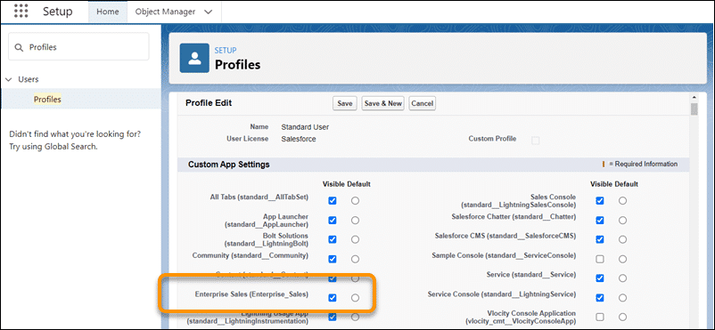

After you've migrated the required components to the target org, ensure that the users in that org have the required permissions on the migrated Enterprise_Sales custom application.

To provide permissions to this custom app in the target org:

1. Go to Settings and click **Setup**.
2. In Quick Find, enter Profiles and then click **Profiles**. Alternatively, you can first go to **Users**and select the user you want to grant permissions for. Look for the profile associated with that user.
3. Click the profile that you want to update.
4. Click **Edit**.
5. In the Custom App Settings section, go to **Enterprise Sales** and select the **Visible**checkbox.
6. Click **Save**.

**Add Custom Buttons to Layouts**

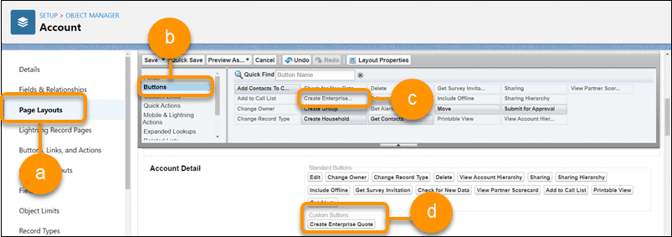

After you've migrated the ESM components, the custom buttons you use to launch and perform actions in ESM, such as Configure Enterprise Quote on the account page and Create Proposal on the quote page, won't appear on the page layouts automatically. You must add these custom buttons to the Account, Opportunity, and Quote objects' page layouts.

To update the page layouts in the target org:

1. Go to Settings and click **Setup**.
2. Click **Object Manager**.
3. In Quick Find, enter Account and then click the **Account**label from the Object Manager list.
4. From the view options on the left, click **Page Layouts** (a).
5. Click the page layout that you want to update. For example, click **Account Layout**.
6. Select **Buttons**from the filter options (b) in the Account Layout pane, then from the list of buttons, select **Create Enterprise Quote**(c) and drag and drop it into the **Custom Buttons** section (d).
7. Click **Save**.
8. Repeat these steps to update the opportunity and quote page layouts with the QuoteCreate buttons, then add the ProposalCreate button to the quote page.

**Deploy Cards with LWCs**

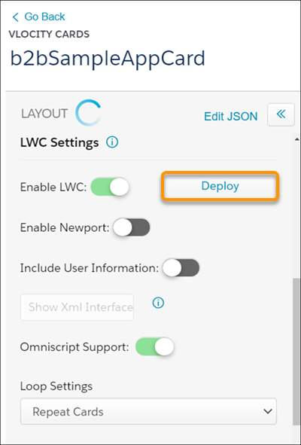

To enable the ESM b2bSampleApp card in your org to work with Lightning web components (LWCs), follow these steps to deploy the card with LWCs. You can learn more about LWCs and this process in the Customize ESM course.

1. In the App Launcher, in the Quick Search, type *Cards*to find the Cards app. Click **Vlocity Cards**.
2. In **Find in page** at the top of the page, type *b2b* to locate the b2bSampleAppCard in the list of cards.
3. Expand b2bSampleAppCard and then click the active version.
4. In the **LWC Settings** section of the card, check LWC is enabled, then click **Deploy**.

A card named cfB2bSampleAppCard is deployed. Ensure your b2bSampleAppCard is active before moving to the next step.

**Activate Document Templates**

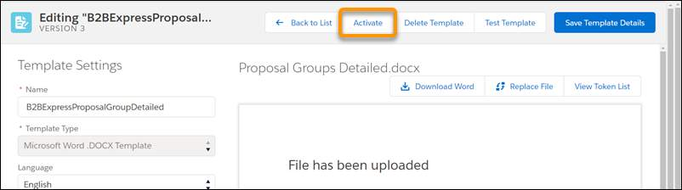

There are four document templates which require activation as part of the ESM installation process. These are:

* B2BExpressProposalGroupDetailed
* B2BExpressProposalGroupSummary
* B2BExpressProposalMemberDetailed
* B2BExpressProposalMemberSummary

The steps here explain how to activate the B2BExpressProposalGroupDetailed document template, but you’ll need to repeat this process for each of the four templates when you complete a new installation of ESM.

1. Click on the **App Launcher**, and in the Quick Search type *Template*to locate the Vlocity Document Templates app. Click **Vlocity Document Template**.
2. You’ll see all four templates listed. Expand **B2BExpressProposalGroupDetailed** and then click the latest version.
3. Click **Activate**, then click **Yes, Save Template**.
4. Click **Back to List** to return to the list of templates and repeat the process for the remaining templates.

**Set Up the Asset Subtab on the Account Page**

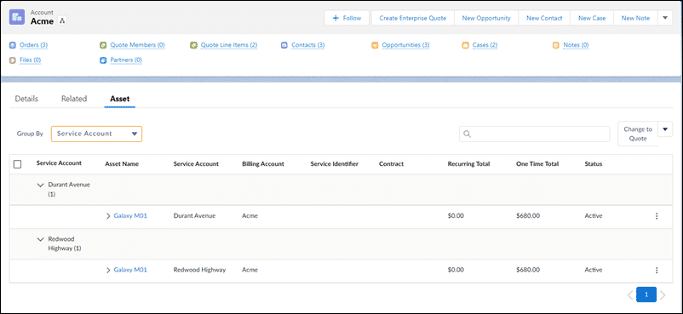

The Asset Viewer used in ESM has extra features that allow you to easily find information inside a list of assets. These lists are often extensive for large enterprise customers.

The ESM Asset Viewer displays additional columns, and can group the asset list by asset name, service account, billing account, or asset status. To enable this feature, you’ll set up your account page to display the custom LWC b2bAssetViewer.

1. Click the Settings icon and select **Setup**.
2. In Quick Find, enter *Lightning*and select the **Lightning App Builder**.
3. If you want to use the default account page:
   1. Go to the Default Account (Enterprise Sales Management) Record Page and click **View**. The Asset subtab is already available on this page.
   2. Make any changes, if required, and then click **Save**.
4. To add the b2bAssetViewer component to a Lightning record page:
5. Go to the page that you want to clone or edit, or create a new page.
6. Click in the tabs section of the page and then click **Add Tab**.
7. Click the new tab to edit its label.
8. In Tab Label, select **Custom**.
9. Enter *Asset*as the custom label and then click **Done**.
10. In the layout, click the new tab.
11. In the list of components, scroll down to the *Custom - Managed* section. Drag and drop b2bAssetViewer onto the new tab.
12. Click **Save**.

**Activate A Custom Record Page**

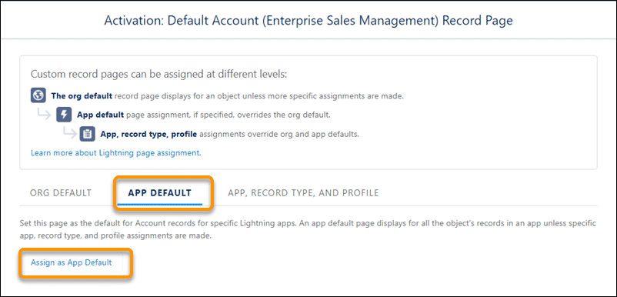

If you have a custom record page, such as a custom Account page, you'll need to ensure that is activated as the App Default.

1. On the Lightning record page that you want to use, click **Activation**.
2. Click **APP DEFAULT**.
3. Click **Assign as App Default.**
4. Select **Enterprise Sales**and click **Next**. Desktop and phone is selected by default.
5. Click **Next**.
6. Click **Save**.

**Using Frame Agreements? - Create a New Pricing Plan Step**

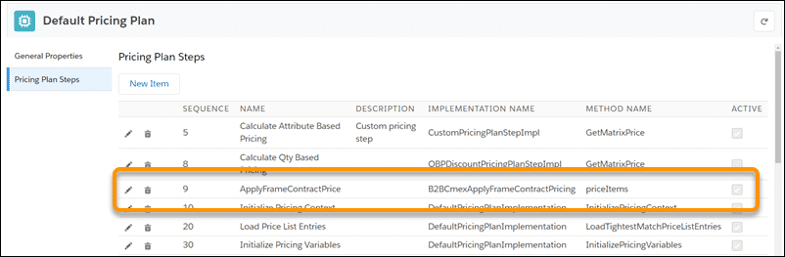

Frame agreements are often used in ESM to apply a negotiated, contract-based discount on various products. To use frame agreements in your enterprise quotes, add the required pricing plan step to the default pricing plan in your org.

* Go to the App Launcher. Under **All Items**, click **Vlocity Product Console**.
* Under Pricing, click the search icon next to Pricing Plan, then click the Search icon on the search page to display all pricing plans.
* Go to Default Pricing Plan and click the **Edit** icon.
* Click **Pricing Plan Steps** from the options on the left.
* Ensure that the step for ApplyFrameContractPrice is included. If this step isn't included, click **New Item** to create a new step with these properties:

|  |  |
| --- | --- |
| **Field** | **Detail** |
| Name | ApplyFrameContractPrice |
| Description | Apply Frame Contract Pricing |
| Implementation Name | B2BCmexApplyFrameContractPricing |
| Method Name | priceItems |
| Sequence | 9 |
| Active | ✔ |
| Parameters | (leave blank) |

Don’t forget to click **Save**to save your new step once you’re done!

**Using Google Maps Integration? - Add Your API Key**

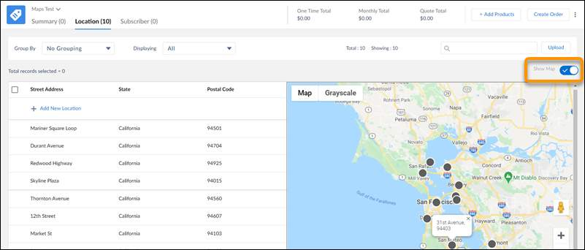

ESM’s integration with Google Maps allows your salespeople to quickly locate and select locations and subscribers on an enterprise quote. The steps for creating and adding your Google Maps API key are covered in detail in the Out-of-the-Box Integration lesson in the ESM Developer course. Alternatively, you can follow the steps covered in Create and Add Your Google Maps API Key, which is linked in the Resources section of this lesson.

**Verify Future Dated Order Status Configuration**

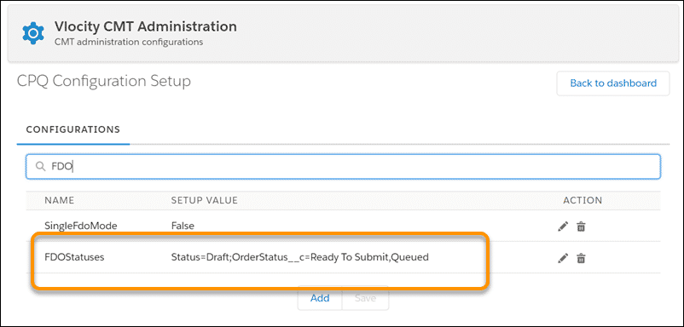

In the CPQ Configuration Setup, the statuses for future dated orders (FDO) are set by default. However, in the target org the default setting could have been modified. To ensure that ESM works as expected in the target org, you should check that the FDO statuses are set to the default value. To verify the FDO statuses:

1. Click on App Launch and in Quick Search type CMT. Select **Vlocity CMT Administration**.
2. Under **Custom Settings**, click **CPQ Configuration Setup**.
3. In the Search field, enter *FDO*.
4. For **FDOStatuses**, ensure that the **Setup Value** is:  
   Status=Draft;OrderStatus__c=Ready To Submit,Queued.
5. If required, edit the value to update it, then click **Save**.

**Verify or Update Custom Settings**

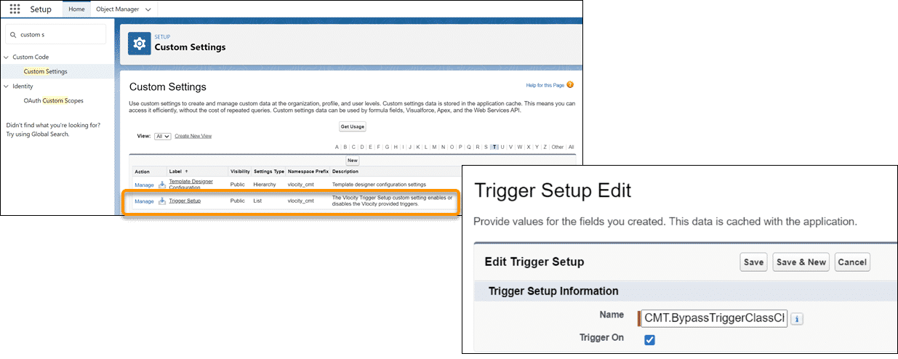

It's probably fine, but it's best to check that the appropriate custom settings are specified for Trigger Setup in your org.

1. From **Settings**, click **Setup**. Then in Quick Find, enter Custom s and select **Custom Settings**.
2. Check the **Trigger Setup** settings.
   1. Go to**Trigger Setup** and click **Manage**.
   2. Verify that **CMT.BypassTriggerClassCheck**exists and is enabled. If this trigger doesn't exist, then create it by clicking **New**.
      1. In **Name**, enter *CMT.BypassTriggerClassCheck*.
      2. Click **Trigger On**.
   3. Click **Save**.

**Check the XOM Setup Settings**

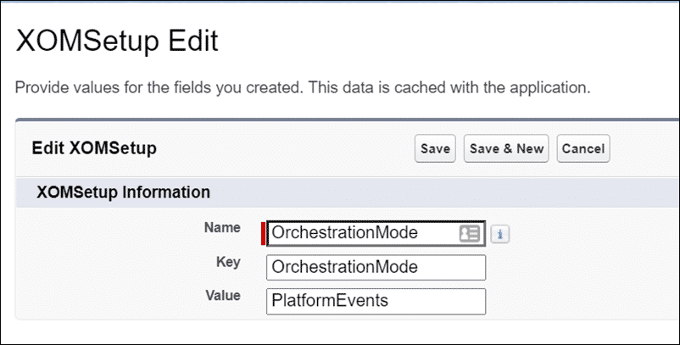

The final step in the post-migration process is to check that the appropriate custom settings are specified for XOM Setup in your org.

1. From Settings, click **Setup**. Then in Quick Find, enter *Custom s* and select **Custom Settings**.
2. Click **Custom Settings** again to go back to the list of custom settings.
3. Go to **XOM Setup** and click **Manage**.
4. Go to **OrchestrationMode** and click **Edit**to see the dialog shown here.
5. In **Value**, replace *BatchApex* with *PlatformEvents*.
6. Click **Save**.

**Wrap Up**

If you followed the post-install steps, you probably noticed that you didn’t actually need to change much and that most of the settings were already correct. That’s often the case. This post-migration lesson was designed to show you the types of things you need to check after an upgrade or migration, and not all settings will be altered in every migration.

**Proposal Development in ESM**

Salespeople use ESM to generate proposal documents based on an enterprise quote's offer configuration, pricing, and the account's discount scheme and contract term. Proposals can include marketing material added dynamically based on products in the quote.

Behind the scenes, ESM uses Foundation Document Generation (DocGen) to generate proposal documents based on templates created in the Contract Lifecycle Management (CLM) application. Once a proposal is generated, it may be sent to your customer, and an associated proposal record is added to the customer’s account page. Your organization may use CLM to associate and manage a lifecycle for each proposal. This is important when you need to:

* Iterate through several rounds of pricing negotiations, approvals, and proposal versions.
* Negotiate the terms and conditions of a contract.
* Manage the contract signature steps.

Contracts differ from proposals, as they often contain more legal terminology and fewer product benefits. Need to generate dynamic contracts separate from the proposals? Use the same CLM module and just create new document types and clauses.

Actions, OmniScripts, and Integration Procedures

Out of the box, proposal generation is triggered in ESM by clicking the **Create Proposal** option in the action dropdown menu on the quote.

This invokes the **b2bExpressCLM/generateProposalDocumentLWC** OmniScript.

This OmniScript calls an integration procedure called B2BExpress_TemplateConfigData. This integration procedure gathers the quote data together and creates a JSON file, which can be used as the data source for the associated CLM proposal template.

The OmniScript then requests information from the user:

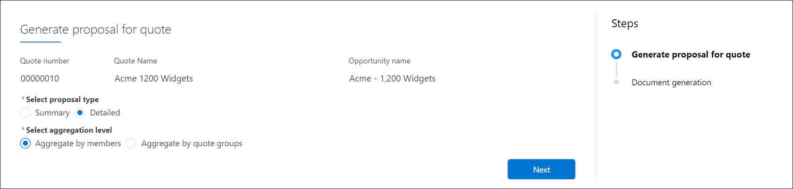

The user is asked to select whether they want a summary proposal or a detailed proposal. Once their response is collected, they are asked to specify how they want their proposal aggregated: by member or by quote group. The user’s responses determine the proposal template used by DocGen to create the proposal for the quote.

**Actions, OmniScripts, and Integration Procedures**

There are four ESM proposal templates available out of the box. These are:

| **Proposal Template Name** | **Used to Generate the Proposal if the User Chooses...** |
| --- | --- |
| B2BExpressProposalGroupDetailed | A Detailed proposal type aggregated by quote groups. |
| B2BExpressProposalGroupSummary | A Summary proposal type aggregated by quote groups. |
| B2BExpressProposalMemberDetailed | A Detailed proposal type aggregated by members. |
| B2bExpressProposalMemberSummary | A Summary proposal type aggregated by members. |

Each of these templates has been created as a Microsoft Word.docx template and uses JSON based data mapping to add quote information to the proposal.

You can create new versions of the existing proposals and then edit them to suit your requirements, or you can clone them to extend the options available to your users. If required, you can create entirely new templates to be used in your organization.

**Amending an Existing ESM Template**

Generally you’ll need to make only basic amendments to the templates, which is a straightforward process.

**Open the Document Template Designer**

From the **App Launcher**, in Quick Search type **Document** and select **Document Template Designer.** You’ll see the four document templates discussed earlier.

**Create a New Version of the Template**

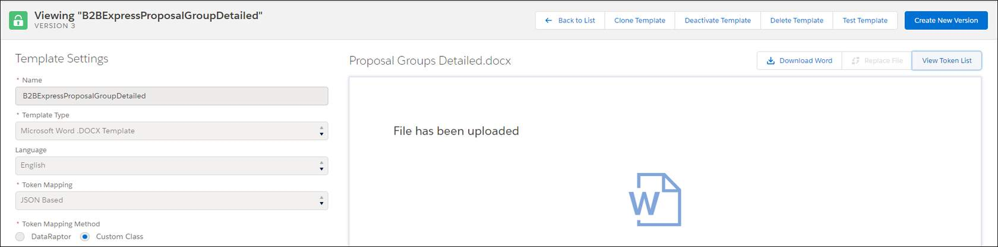

Select the template you want to amend and, once it’s open, click Create New Version.

**Edit the Template**

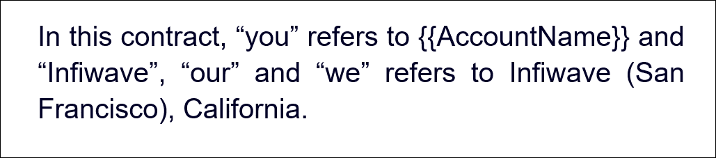

Download the Word template to edit it. You can edit just as you would any other Word document template. Data extracted from the quote, known as tokens, are added to the document using the format {{token}}. So, for example, the Account Name will be automatically filled in on the proposal using information from the quote when the text shown here is added to the proposal template.

**View the Token List**

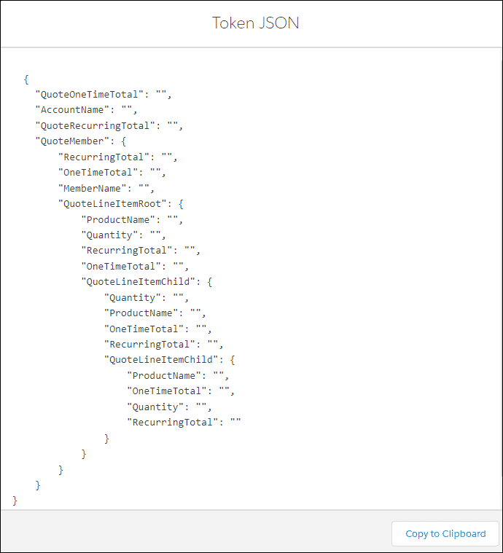

To see a list of tokens available for the current template, click on **View Token List** in the OmniStudio Template Editor. You’ll see the tokens in JSON format, as nested arrays.

**Save and Upload the Amended Template**

Once you’re done making your amendments in Word, save the file and upload it back to your OmniStudio Document Template Designer.

**Test and Activate Your Amended Template**

You can test your template by clicking the **Test Template**button in the designer.  
Don’t forget to activate your template once you’re sure it’s working as it should be, by clicking **Activate**.